Introduction: A major portion of our crops gets damaged every year due to plant diseases. Most of these diseases show symptoms on their leaves and can be identified accordingly. But an expert on identifying these diseases are not available widely. So, we have come up with a solution to make the disease prediction available to the local farmers via cheap smartphones. Farmers can easily take pictures of the leaves. The photo is then analyzed via machine learning and identifies the diseases.

**Motivation:** Bangladesh is an agricultural based country. Agriculture is the largest employment sector in Bangladesh. Agriculture remains the most important sector of Bangladeshi economy, contributing 19.6 percent to the national GDP and providing employment for 63 percent of the population.

The total world potato production is estimated at 388,191,000 tons in 2017 (Source: FAOSTAT, 2019). According to Bangladesh Bureau of Statistic over 10 million tons of potato produced in 2017, and 5.3 million tons of potato kept in 390 cold storages across the country to maintain a sustainable supply during the year. In 2006-07 the total production of tomato in Bangladesh was 1,19,935 tons (BBS, 2007) and the loss was estimated approximately 39,146 tons (32.64%).

In our project we are trying to help in this important sector of Bangladesh. Our model identifies the diseases of the crops from a picture of the disease. It will help the farmers to take actions against the disease immediately. So that we can save million tons of crops which will help us to feed our population and earn millions of dollar by exporting them.

**Background Studies:** The origins and continued evolution of agriculture in the face of infectious diseases and pests Perhaps the greatest technological advance that humans have ever made has been the domestication of plants during the agricultural revolution. The development of systems to monitor large fields using the Normalized Difference Vegetation Index (NDVI) started more than 25 years ago when Normalized Difference Vegetation Index (NDVI) was used in the so-called remote sensing field. It was an important milestone in the advance of automatic methods for analyzing plant growth and biomass. Ever since, new technologies have increased our capacity to obtain data from biological systems. The ability to measure chlorophyll status from satellite images allowed plant health to be measured in large fields and predict crops and productivity in very large areas such as the Canadian, the Indian in Pakistan. Thus, the field of remote sensing is an important basis where knowledge about data acquisition and analysis started.

Recently, high-throughput analysis methods are commonly used in molecular biology. High-throughput phenotyping has been introduced to capture phenotypical data in larger quantities. Automated greenhouses, in which plants are grown and analyzed automatically and images are taken in regular intervals, are the basis for high throughput phenotyping for plants. Image analysis software augments an observer’s ability to evaluate plant phenotypes. For this purpose, various fully automatic high-throughput plant growth and phenotyping platforms have been developed.

**Implementation:** We have implemented our project by using Convolutional Neural Network (CNN). Although the model is focused on potato, tomato, apple diseases detection it can be trained using different leaf dataset and can be later modified for potato, tomato, apple diseases detection. The datasets have to be divided into three portions for Training, Cross-Validation and Testing with a ratio of 60:20:20. The model has been uploaded on our server. Pictures have been taken through android app and will be send to our server for processing.

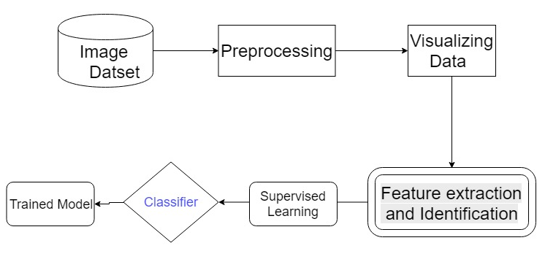

**Pre-Processing:** The collected images need to be preprocessed before any classification and training can be done. The blurry and low-quality images need to be corrected. Using Median, the blurry images can be corrected to some degree. A good PSF (Point Spread Function) is needed that will correct the blurred images most. The image has to be converted to grayscale to reduce the dimension of image and detect the contour of leaf. The disease area and shape can be extracted from the greyscale image easily.

**Model Training:** The model has been trained with potato, tomato and apple plant diseases which contains 7500 images. We used supervised learning for training purpose. The dataset is an open source dataset collected from CrowdAI competition. We have used Convolutional Neural Network (CNN) algorithm in our model. The datasets had to be divided into three portions for Training, Cross-Validation and Testing with a ratio of 60:20:20. Although the model is focused on potato, tomato and apple plant disease detection, it can also be trained using different plant dataset and can be modified later for particular plant disease detection.

**Test Result:** We received 98.54% test accuracy for the test data.

**Model Deployment:** We have deployed the model in a cloud Virtual Machine (VM) using docker. The virtual machine can handle large amount of concurrent processing in a short amount of time for faster result.

**Android App:** This is a very convenient app. It only takes camera and storage permission from the users. It only takes 14-15 MB of storage. Data usages of this app is too low because we resize the pictures first and then send tShem to our server. About 150 pictures can be processed by using only 2MB of Data package. The app is also friendly in terms of battery drainage and data usages. It also drains battery a little because all the functions have been done on our server. The app is mainly used for taking the input and showing the output.

**Bangla Feature:** Though this app is for our farmers, we have tried to make it more user friendly to them. We have used Bangla fonts and Bangla voice assistance in our app. So that it could be more understandable to them.

**Outcomes:** Our users will be able to find out the diseases of potatoes, tomatoes, apples etc. by using our app. This project will help our farmers to take necessary steps before it is too late. We would save million tons of crops every year by taking precautions at the early stage. This is an ideal neural network model where it allows to add more crop diseases as extension of the model. For this, we need the datasets of specific plant diseases. This model tries to predict the disease accurately. But as it is a Machine Learning model, the prediction won’t be accurate all the time.

**References:**

[1] Ferentinos, Konstantinos P. “Deep Learning Models for Plant Disease Detection and Diagnosis.” Computers and Electronics in Agriculture, vol. 145, 2018, pp. 311–318., doi:10.1016/j.compag.2018.01.009.

[2] Ferentinos, Konstantinos P. “Deep Learning Models for Plant Disease Detection and Diagnosis.” Computers and Electronics in Agriculture, vol. 145, 2018, pp. 311–318., doi:10.1016/j.compag.2018.01.009.

[3] Tucker C**.** Red and photographic infrared linear combinations for monitoring vegetation. *Remote Sens Environ*. 2016.10.16

[4] <https://www.potatopro.com/world/potato-statistics>

[5] <http://en.banglapedia.org/index.php?title=Potato>